Promoting A Just Society:

A Focus On What Works

3 ~ 10 December 2012

*Draft Overview*

Resolution 58/4 of 31 October 2003 marked the adoption by the UN of the Convention Against Corruption, showing concern at the highest levels for ways to move society world-wide forward in their efforts to deal with corruption in all its forms.

In 2011, the Alliance marked the International Anti-Corruption Day with dialogues facilitating collaboration amongst experts, stakeholders and governments. This year, in preparation for the International Day, the Alliance is inviting its members, associates and interested parties including governments and intergovernmental groups to co-sponsor “Promoting A Just Society 2012” and to contribute to the week by holding a discussion, forum, keynote address, symposia, presentation of promising practices or some other event during the week of December 3 - 9, 2012 to add to the collective focus on innovative efforts, strategies, and/or constructive dialogues**.**

This year’s focus on what works at all levels, including the individual, family, community, state, regional and international levels is already planned to take place in locations around NYC, in New Jersey and Washington DC, and we also invite interested parties to link their events, topics and findings to the Week to further highlight practices and approaches that constructively contribute to the diminishment of corruption.

To report and to highlight the collective work of organizations and people worldwide at the highest levels, we will hold an event at UNHQ on Thursday December 6th during which the Alliance will invite key UN Departments and Member States both to co-sponsor, to participate and to report to their respective ministers.

There are three ways individuals, organizations, Member States, and both Civil and the Private Sector can participate and you are invited to choose one or more. You can indicate your intention by submitting your intention online or by calling 914.630.4339:

* **Sponsor an Event** and adding it to the list of events being held during the week and that will be disseminated widely in the UN and Crime Prevention and Criminal Justice communities. All those who sponsor an event will automatically be considered a co-sponsor.
* **Co-Sponsor the Week**: Add your organization’s name to the Co-Sponsor’s List: http://cpcjalliance.org/events/just-society-2012/.
* In late September you will be able to see the current list of sponsors here: http://cpcjalliance.org/events/just-society-2012/sponsors/
* **Support the Week** as a Donor (100% of your donations will be used for the expenses associated with costs of the week. Tax-Deductible donations can be made through WFWP International. Direct non-tax deductible donations can be made online here: (The Alliance is a committee of NGOs and is therefore not itself a 501(c)(3) entity in the USA.)

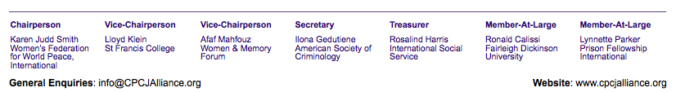

We look forward to your participation and contribution to the 2012 Week of “Promoting A Just Society: A Focus On What Works.”

**eMail**: [JustSociety@CPCJAlliance.org](mailto:JustSociety@CPCJAlliance.org?subject=)

**Web**: <http://cpcjalliance.org/about-just-society-2012/>